Reciprocal Vocal Contingency Program Manual

**Purpose**

The reciprocal vocal contingency (RVC) program uses ITS files from the Language ENvironment Analysis (LENA) system to tally events for the 4 cells a 2×2 table for the 3-event sequence of child vocalization 🡪 adult vocalization 🡪 child vocalization (CV 🡪 AV 🡪 CV).

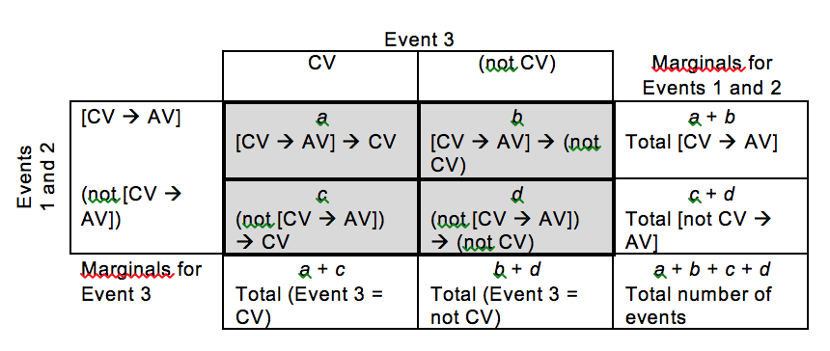

Event 1 = CV

Event 2 = AV

Event 3 = CV

For each ITS file, the output can then be used to calculate the operant contingency value (OCV), which is the metric for child RVC. LENA Pro software labels CV as CHNSP and AV as MAN and FAN. More detail is below.

**A. Organize ITS files**

“The ITS file is a user-friendly, exportable XML-formatted compilation of all algorithmic analyses of the original audio data file” (Xu, Yapanel, Gray, & Baer, 2008, p. 7). It includes an audio header, an algorithm version section, key child information, and segmentation information.

1. Name ITS files in such a way that they can be matched with each participant.
   1. It is recommended that the participant’s ID and time period be included in the ITS file name (e.g., V149 T1 e20160106_183709_005233.its). In this example the study ID (V149) and the period (T1) have been added to the beginning of the file name that the LENA pro system assigns to the file. If multiple audio samples were collected at one time period, include something in the file name that will differentiate them (e.g., V149 T1a, V149 T1b…). This enables the output of the current program to contain the study ID and period.
2. Place all ITS files to be analyzed in a single folder. The program will run all the ITS in this folder and place the output in a single .csv file. The group of ITS files is called a “batch.”

**B. Download the RVC program**

1. Go to <https://github.com/HomeBankCode/LENA_contingencies>

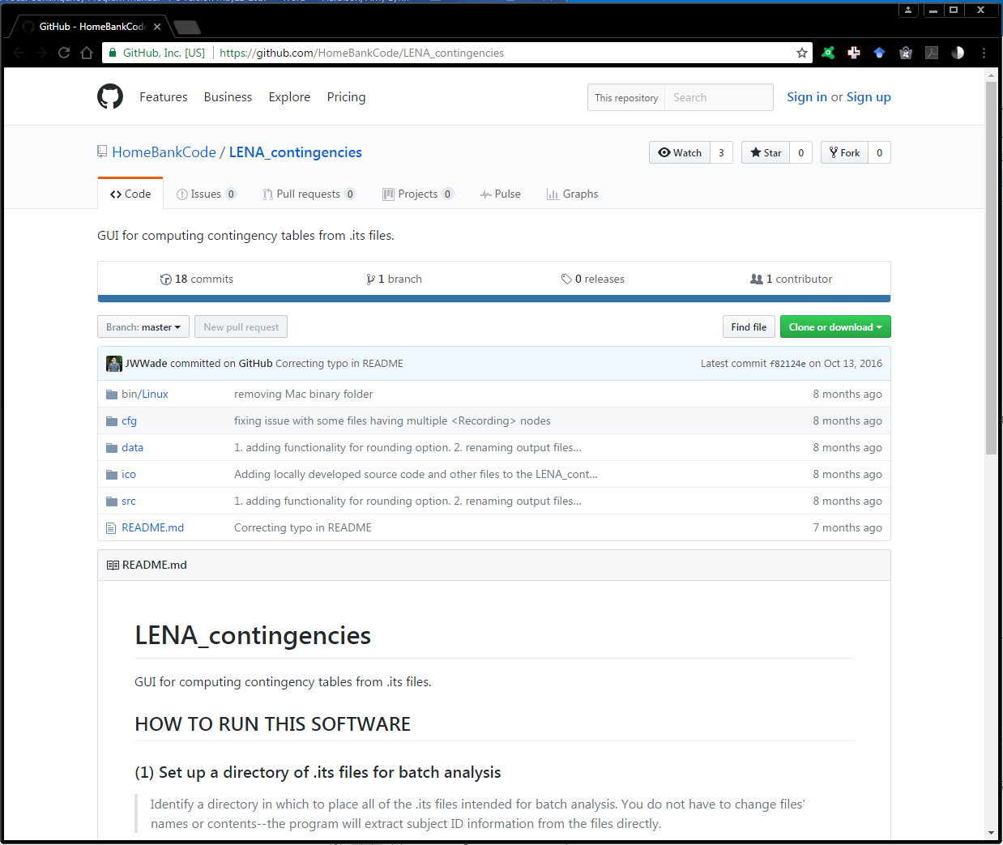

1. Click on the Green box for “Clone or download”.

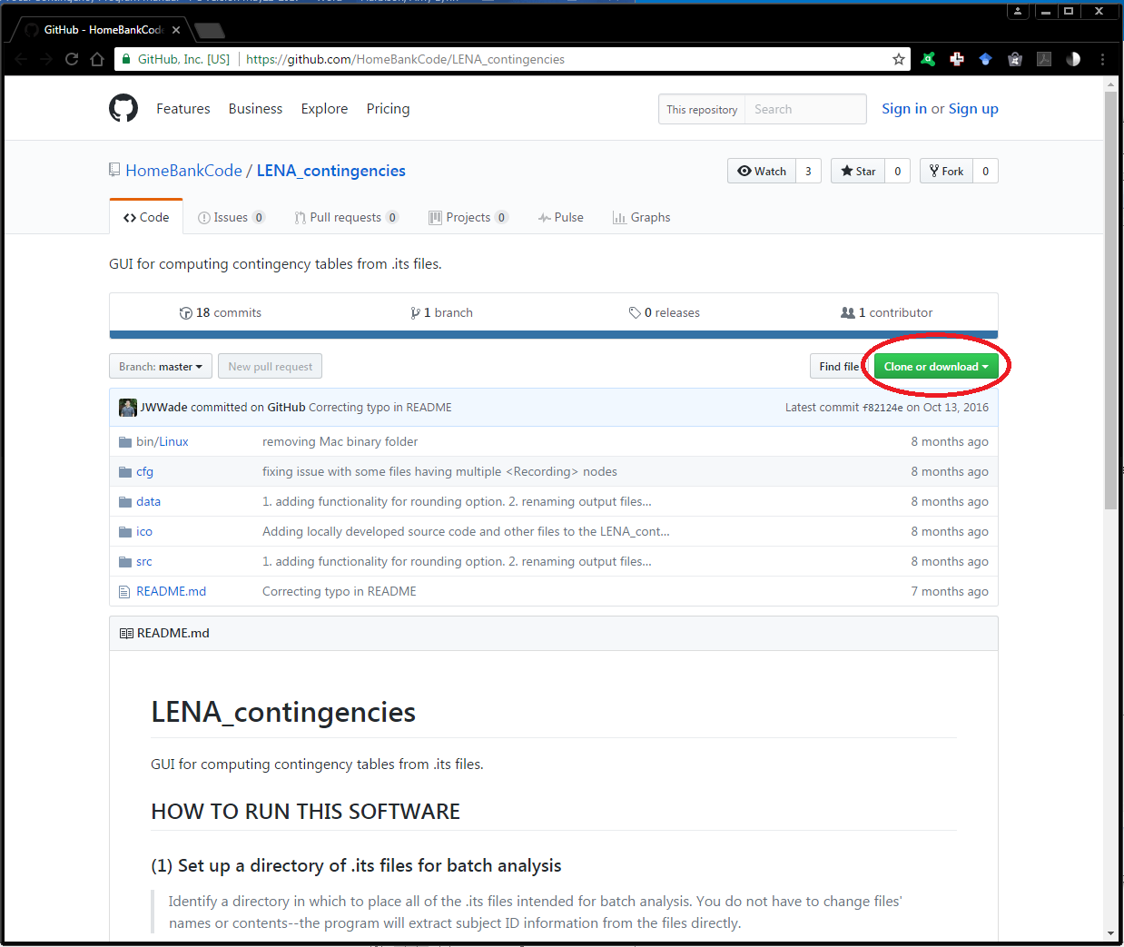

1. Click on “Download ZIP”.

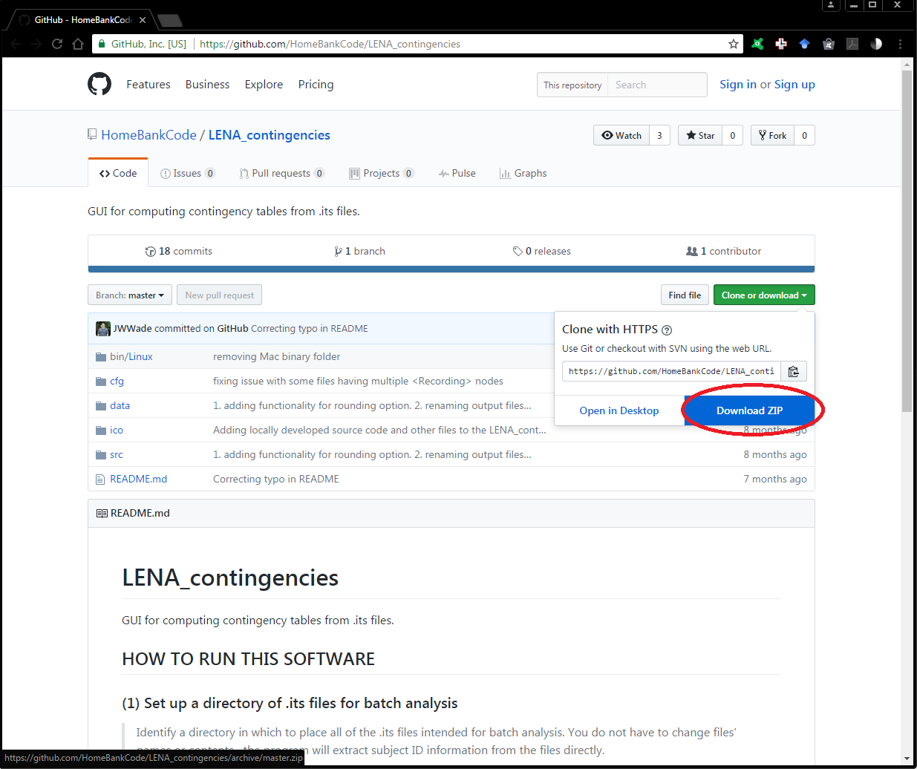

1. A zipped folder called “LENA_contingencies-master” will be located where your downloads appear on your computer.

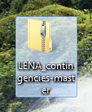

1. Double left click on the zipped “LENA_contingencies-master” folder to open the contents. This will open a new Windows Explorer window called “LENA_contingencies-master”. Find subfolder file that is also titled “LENA_contingencies-master”. 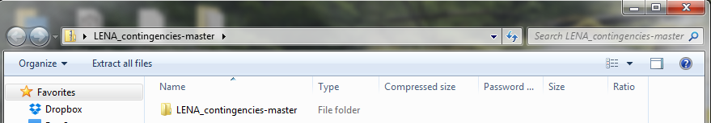
2. Move the subfolder onto the desktop (or other convenient location).

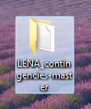

**C. Open the RVC program**

1. **To complete this step and use the program on a Windows computer, you will first need to download and install Python.** The necessary files and instructions are available at <https://www.python.org/downloads/>. **The particular version of the python to download should be the python2.7. Follow instructions for installing. In Windows 10, select “run”. You should see windows and instructions for ‘set-up’. The instructions used “customize installation” and changed the directory to “c:\”. When complete, select “close” or “finish”. Open (windows or file) explorer to identify what directory and filename for the ‘.exe’ file.**
2. Open the Command Prompt window. To do this, open the start menu, select All Programs, choose the Accessories folder, then click on Command Prompt. Alternatively, use the search function (i.e., magnifying glass icon in task bar) to find the Command Prompt application and select it.

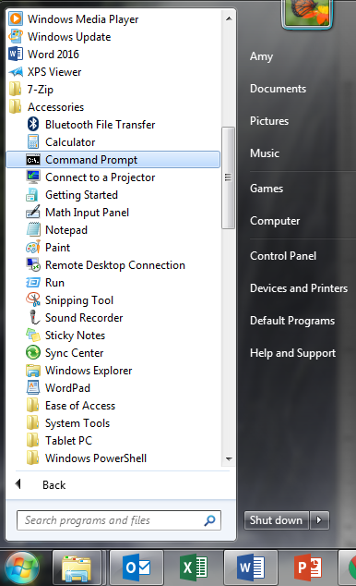

1. A screen similar to the following will open. The details of the computer name (e.g., “Amy”) will be specific to your computer.

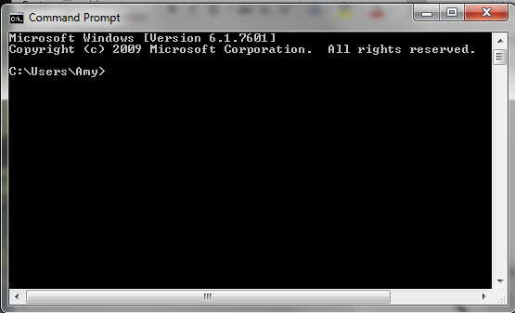

1. Use file explorer to identify the directory in which you directed the installation program to store the python27 file. These instructions placed the file in the local disk (c:\).
2. Enter text into the Command Prompt window.
   1. First, type in the path for your python.exe file. The exact text will depend on where you installed Python and which version of Python you are using. In the image below, “c:\python27\python.exe” is the path for the python.exe file.
   2. Type a space.
   3. Then, type the path to your LENA_contingencies-master folder (see Step B6), followed by “\src\control.py”. For example, in the screenshot below, “c:\users\amy\desktop\lena_contingencies-master\src\control.py” indicates that the folder from Step B6 is on the Desktop.
   4. Press Enter.

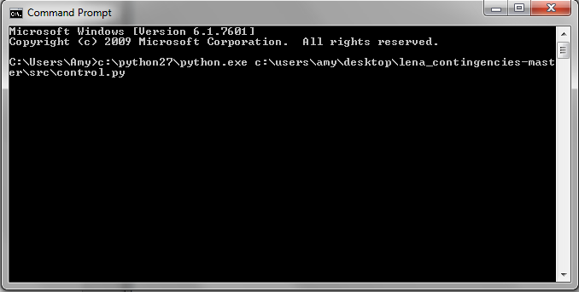

1. The following window will appear. This is the step that is most likely to produce a problem. Please follow these instructions exactly, if you can. This window is for the RVC program. It is run by Python, so the Command Prompt window must remain open for the program to work. You are now ready to input your ITS files as a single batch.

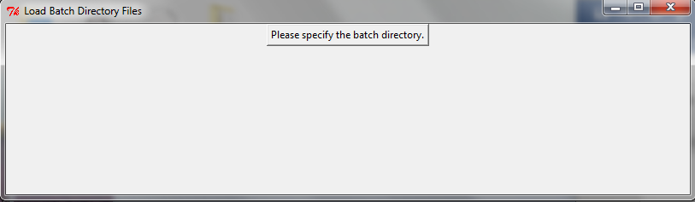

**D. Input and Run ITS Files Using RVC Program**

1. Click on “Please specify the batch directory.”
2. Navigate to the LENA ITS files you want to analyze and click “Choose”. The ITS files will all be in the folder you moved them to in Step A2. Open the folder and then click “Choose” even though the files are greyed out and may appear that nothing is selected.
3. The following window will appear. Contingencies for two-event or three-event sequences can be computed. 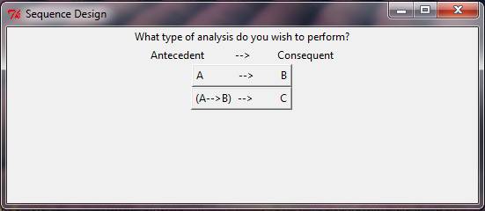
4. Click on “(A🡪B) 🡪 C” because RVC is a 3-event contingency.

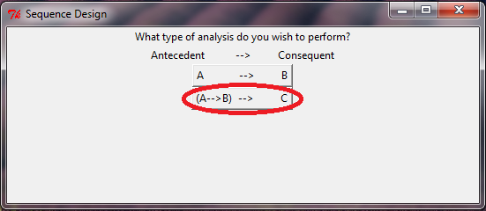

1. Fill in your three events from the three dropdown menus, each of which is activated by selecting the radio button corresponding to the position you want to designate an event type.
   1. For RVC, select the following:
      1. “CHNSP” (i.e., child – near – speech-related) for the first event

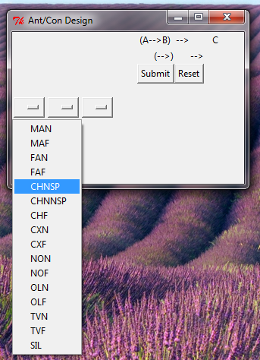

* + 1. “MAN” (male adult – near) for the second event

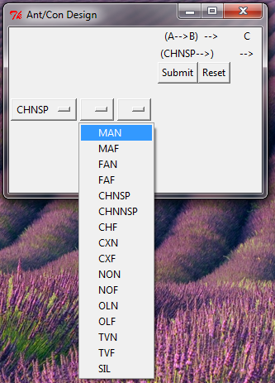

* + 1. Also for the second event, select “FAN” (female adult – near). By clicking on “FAN” in the second dropdown, the program will add that type of vocalization to the second event. We want both male and female adult vocalizations to be included in adult vocalizations.

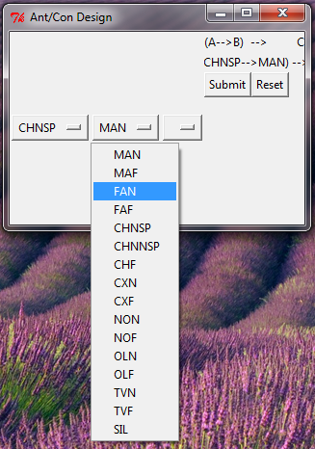

* + 1. Select “CHNSP” (i.e., child – near – speechlike) for the third event

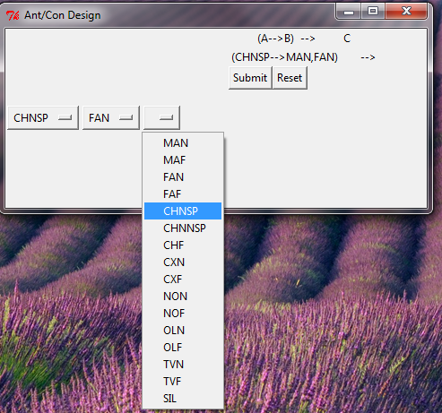

1. The program will display the sequence you have selected. If you make an error in this process, click “Reset” and start again.

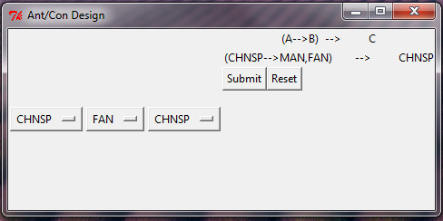

1. Click “Submit”
2. Select pause length and rounding preferences.
   1. For RVC, a pause length of 2 seconds is based on the 2 second being the average latency between mother and infant vocalizations (Northrup & Iverson, 2015).
   2. To adjust the pause length, drag the marker along the sliding bar.

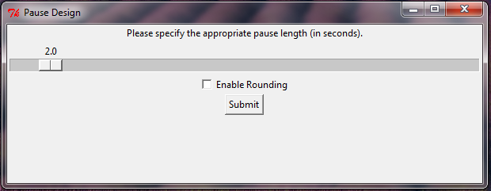

* 1. You can enable rounding or not. It is recommended that you do NOT enable rounding. Enabling rounding reduces the precision of the results.

1. Click “Submit” and wait. It can take a few minutes for the program to run all the ITS files depending on how many are in the batch.
2. After the program has completed its run, the following window will appear. Click on “Please select the desired output directory”.

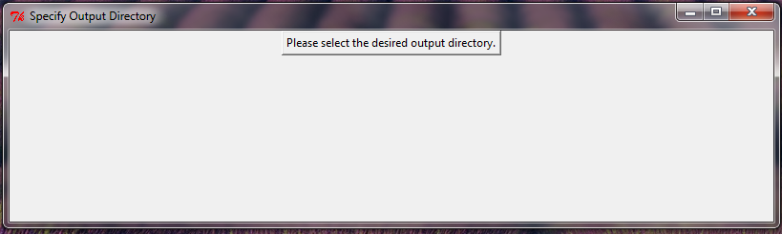

1. Navigate to the location you want the output .csv file to be saved and click “OK”.
2. Go to the location you selected to find the output and double click to open it. If you see either of the following warnings, click “Yes” or “OK” to continue.

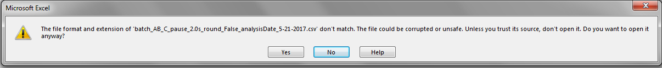

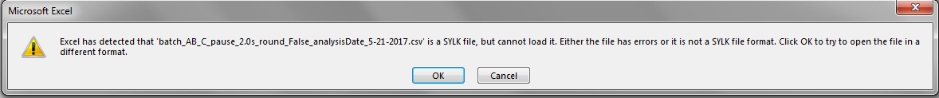

1. You may close the Command Prompt window if you are not planning to run additional ITS batches at this time.

**E. Interpreting the output and calculating RVC operant contingency values**

1. You will see values in the following columns

|  |  |  |  |  |  |  |  |  |  |
| --- | --- | --- | --- | --- | --- | --- | --- | --- | --- |
| ID | its_filename | CHNSP | MAN+FAN | CHNSP | Pause | a | b | c | d |

ID = This is a useless column. Ignore it. It is the ID LENA Pro designates. It won’t correspond with other variables in your study.

CHNSP = Number of key child’s vocalizations that are near and speech-related

* These child vocalizations include words, babbling, phones, and protophones (i.e., squeal, growls, or raspberries; Xu et al., 2008)

MAN+FAN = Sum of the number of male adult vocalizations and adult female vocalizations that were near the key child

CHNSP = Number of key child’s vocalizations that were speech-related. Note that the values in the two CHNSP columns are identical because the 1st and 3rd event type are identical. If you use the program to compute a contingency for three unique event types, the 5th column will differ from the 3rd column.

Pause = Number of pauses of the defined length (e.g., 2-second pauses).

* Pauses occur at times the original ITS file contained “silence, noise, overlapping speech, distant or faint speech, child or adult vegetative sounds, child or adult fixed signals, or electronic noise (e.g., television or radio)” (Xu et al., 2008, p. 6). The current program inserted these when neither a CHNSP nor MAN+FAN occurred for the indicated interval (e.g., 2 s).

a = Tallies in the *a* cell of the 2 x 2 contingency table, which is the number of [CV 🡪 AV] 🡪 CV sequences in the event stream

b = Tallies in the *b* cell of the 2 x 2 contingency table, which is the number of [CV 🡪 AV] 🡪 (not CV) sequences in the event stream

c = Tallies in the *c* cell of the 2 x 2 contingency table, which is the number of (not [CV 🡪 AV]) 🡪 CV sequences in the event stream

d = Tallies in the *d* cell of the 2 x 2 contingency table, which is the number of (not [CV 🡪 AV]) 🡪 (not CV) sequences in the event stream

1. To calculate the operant contingency value (OCV aka RD) for RVC, use the formula a/(a+b) – c/(c+d). You may enter this formula in Excel to easily generate the RVC values. For example, G2/(G2+H2) – I2/(I2+J2). **These OCVs are the RVC scores for your participants.**

**F. References**

Northrup, J. B., & Iverson, J. M. (2015). Vocal Coordination During Early Parent-Infant Interactions Predicts Language Outcome in Infant Siblings of Children with Autism Spectrum Disorder. *Infancy, 20*(5), 523-547.

Xu, D., Yapanel, U., Gray, S., & Baer, C. T. (2008). The LENA™ Language Environment Analysis System: The Interpretive Time Segments (ITS) File. *LENA Research Foundation Technical Report LTR-04-2*.